  Seed | 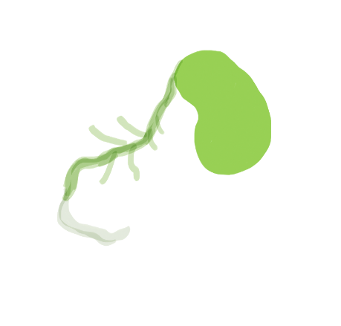  Germination | 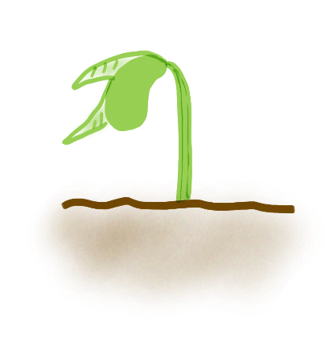  Seedling | 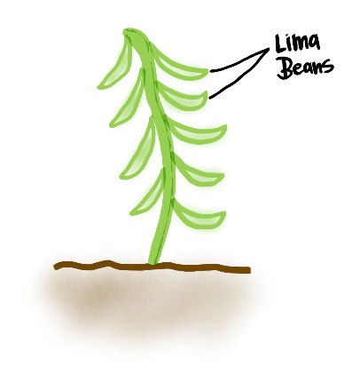  Adult Plant
Seed | Germination | Seedling | Adult Plant
Seed | Germination | Seedling | Adult Plant

